**Data Science Masters Research Proposal**

Detecting Machine Generated Text

Candidate Number:

Advisor:

MSc Data Science, University of Sussex, Brighton, UK

June 2024

**Abstract**

This project proposes the development of robust methods for detecting machine-generated text, addressing the pressing need to differentiate between human and AI-generated content. By leveraging advanced natural language processing techniques and machine learning algorithms, the research aims to enhance cybersecurity measures, combat misinformation, and uphold the integrity of online communication. Through the implementation of comprehensive evaluation metrics and comparison with existing approaches, the study seeks to contribute to the advancement of detection technology in safeguarding digital environments.

**Table of contents**

1. Introduction...........................................................……..............................................3
   1. Significance in Today's Context...........................……...............................….............3
   2. Importance of Detecting Machine-Generated Text…..............................….............4
2. Literature review......................................................………......................................…4
   1. Approaches, Methodologies and Algorithms...............…....................................….5
      1. Recurrent Neural Networks (RNNs)........................…………................................…5
      2. Convolutional Neural Networks (CNNs).........…...........................………................6
      3. Transformer-Based Models.....................................….......................................…7
   2. Strengths and Weaknesses..........…….........................….......................................…7
   3. Identified Gaps.......……..............……………………..........….......................................…8
      1. Methodology.......……..............……………………..........…....…...................................8

3. Data Collection and preprocessing………..………...........…....…..................................…8

3.1 Sources of Data………………....…………………………….......…....…..................................…8

3.2 Considerations for Dataset Quality and Diversity....…....…...............................…….9

3.3 Implementation...…....…....................……………………………………………………...........…..9

3.3.1 Preprocessing and Data Preparation…………………………………………………...........…..9

3.3.2 Feature Engineering.…....................………..…………………………………………...........…..9

3.3.3 Model Selection and Training.........………..…………………………………………...........….9

3.3.4 Evaluation and Validation.........………..………………………………………………...........…10

3.4 Performance Evaluation Metrics for Detection System……………..…………........…...10

3.4.1 Accuracy……………..…………...........……………………………………………………………………10

3.4.2 Precision and Recall…………...........………………………………………………………………….10

3.4.3 F1-Score…………..…………………........………………………………………………………………….10

3.4.4 Area Under the ROC Curve (AUC-ROC).………………………………………………………….10

3.4.5 Area Under the Precision-Recall Curve (AUC-PR)……..…………………………………….11

3.4.6 Confusion Matrix…………………........…………………..…………………………………………….11

3.5 Experimental Setup……………….…......…………………..…………………………………………….11

3.5.1 Data Partitioning…………………........…………………..…………………………………………….11

3.5.2 Experimental Procedure………………........…………..……………………………………………11

4.0 Results Analysis………………………........…………………..……………………………………………11

4.1 Quantitative Analysis………………........…………………..……………………………………………12

4.2 Qualitative Analysis………………........…………………..………………………………………………12

5.0 Conclusion………………........…………………..……………………………………………………………12

References.........………………………………......................................................................…13

**1. Introduction**

In recent years, the rapid advancement of natural language generation (NLG) technologies has revolutionized the way we interact with text. These technologies, ranging from rule-based systems to sophisticated deep learning models, have empowered machines to generate human-like text across various domains, from news articles and product reviews to social media posts and academic papers. While this progress brings unprecedented opportunities for automation, communication, and creativity, it also introduces significant challenges, particularly in discerning between genuine human-authored content and machine-generated text [1].

The proliferation of machine-generated text poses multifaceted implications across various societal domains. One of the foremost concerns lies in the propagation of misinformation and disinformation, commonly referred to as "fake news," which can manipulate public opinion, undermine trust in information sources, and even threaten democratic processes [1]. Moreover, the rise of AI-generated spam, phishing emails, and social media bots exacerbates the challenge of maintaining the integrity and security of online communication channels. Additionally, in academic and professional contexts, the presence of machine-generated content raises ethical concerns regarding plagiarism detection, authorship attribution, and the integrity of scholarly discourse [2].

To address these challenges, there is an urgent need for robust and reliable methods to detect machine-generated text. This necessitates the development of sophisticated computational techniques capable of discerning subtle patterns, linguistic anomalies, and stylistic features that distinguish human writing from automated content generation. Such advancements hold promise not only for enhancing the trustworthiness of online information but also for safeguarding the integrity of academic research, protecting individuals from digital manipulation, and preserving the authenticity of human communication in an increasingly digitalized world.

**1.1 Significance in Today's Context**

The significance of detecting machine-generated text in today's context cannot be overstated [1]. With the proliferation of NLG technologies and the widespread dissemination of digital content, the ability to differentiate between human and machine-generated text has become paramount for ensuring the reliability, credibility, and trustworthiness of information sources. Moreover, as the boundaries between human and machine-generated content continue to blur, the need for robust detection mechanisms becomes increasingly pressing to combat the spread of misinformation, mitigate the risks of digital manipulation, and uphold the principles of transparency and accountability in online communication.

Furthermore, in the era of AI-driven automation and human-machine collaboration, the ability to discern between human and machine-generated text has profound implications for various applications, including content moderation, fraud detection, sentiment analysis, and cybersecurity [2]. By developing effective detection methods, we can empower individuals, organizations, and society at large to navigate the digital landscape with greater confidence, discernment, and resilience against the challenges posed by the proliferation of machine-generated content.

**1.2 Importance of Detecting Machine-Generated Text**

This project proposal aims to address this challenge by developing robust methods for detecting machine-generated text and highlighting its critical importance in mitigating the negative consequences associated with its dissemination.

By accurately identifying machine-generated content, it becomes possible to mitigate the harmful effects of fake news, preserve the credibility of news sources, and uphold the principles of transparency and accountability in online discourse [3]. Furthermore, the detection of machine-generated text is indispensable for enhancing cybersecurity measures, as it enables the identification and mitigation of spam, phishing attempts, and other malicious activities perpetrated through automated means [4]. Moreover, in academic and professional contexts, the ability to differentiate between human and machine-generated text is essential for maintaining the integrity of scholarly research, preventing plagiarism, and ensuring fair attribution of intellectual property [5].

**2. Literature Review**

The literature surrounding the detection of machine-generated text encompasses a diverse array of methodologies, techniques, and applications aimed at distinguishing between human-authored and automatically generated content. A comprehensive review of existing literature provides valuable insights into the evolution of detection methods, the challenges encountered, and the potential avenues for future research.

Various approaches have been proposed for detecting machine-generated text, ranging from rule-based heuristics to sophisticated machine learning algorithms [8]. Early studies primarily focused on lexical and syntactic features, such as n-gram analysis, punctuation patterns, and grammar errors, to identify anomalies indicative of machine-generated content [8]. However, these methods often struggled to capture the nuanced stylistic and semantic differences between human and machine-generated text, leading to limited effectiveness in real-world scenarios.

In recent years, with the advent of deep learning techniques and the availability of large-scale datasets, researchers have increasingly turned to neural network-based approaches for detecting machine-generated text. Models such as recurrent neural networks (RNNs), convolutional neural networks (CNNs), and transformer-based architectures have demonstrated remarkable performance in capturing complex linguistic features and learning representations that enable accurate discrimination between human and machine-generated content [10]. Moreover, the integration of pre-trained language models, such as BERT (Bidirectional Encoder Representations from Transformers), has further enhanced the capability of detection systems to identify subtle deviations from natural language patterns [6].

Despite these advancements, several challenges persist in the detection of machine-generated text. One notable limitation is the adversarial nature of the problem, wherein adversaries continuously adapt their techniques to evade detection mechanisms [9]. Additionally, the inherent variability and diversity of human language pose challenges in developing generalized detection models that are robust across different genres, languages, and domains. Furthermore, the ethical implications of automated content detection, including concerns related to privacy, bias, and censorship, underscore the importance of adopting responsible and transparent practices in the deployment of detection systems [5].

This reflects a dynamic landscape characterized by ongoing advancements, persistent challenges, and ethical considerations. By synthesizing insights from existing research, this project proposal aims to contribute to this evolving field by developing novel methodologies for detecting machine-generated text and addressing key research gaps identified in the literature.

**2.1 Approaches, Methodologies and Algorithms**

This section provides a comprehensive overview of key strategies employed in the field, including recurrent neural networks (RNNs), convolutional neural networks (CNNs), and transformer-based models.

**2.1.1 Recurrent Neural Networks (RNNs)**

RNNs are a class of neural networks designed to handle sequential data, making them well-suited for natural language processing tasks [8]. At each time step, an RNN processes an input element and updates its hidden state, allowing it to capture temporal dependencies in sequential data. The formula for computing the hidden state *ht* at time step *t* involves a linear transformation followed by an activation function:

*ht*​=*σ*(*Wihxt* + *Whhht*−1 + *bh*)

Where

*xt* is the input at time step *t*

*Wih* and *Whh* are weight matrices

*bh* is the bias vector

*σ* is the activation function.

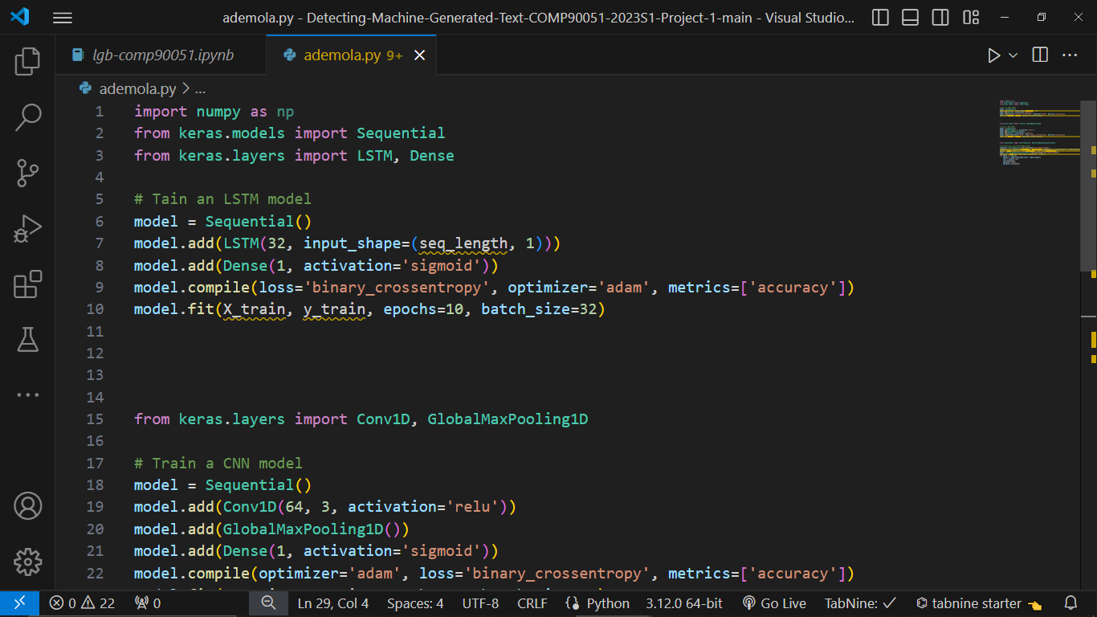

RNNs excel at capturing short-term dependencies and contextual information within sequences. However, they suffer from issues such as vanishing gradients, which can hinder their ability to capture long-range dependencies [10]. Additionally, RNNs are computationally intensive and may struggle with processing long sequences efficiently.

**2.1.2 Convolutional Neural Networks (CNNs)**

CNNs have traditionally been used for image processing tasks but have also found application in text analysis [11]. In text processing, CNNs apply convolutional filters to input sequences to extract local features. The output of a convolutional layer is computed using a weighted sum of input elements, followed by an activation function:

*hi* = *σ*(∑*j*=1*nWij* ⋅*xi*+*j*−1 + *bi*)

Where:

*hi* is the output feature map at position *i*,

*xi*+*j*−1 is the input at position *I* + *j* − 1,

*Wij* are the filter weights,

*bi*​ is the bias term, and

*σ* is the activation function.

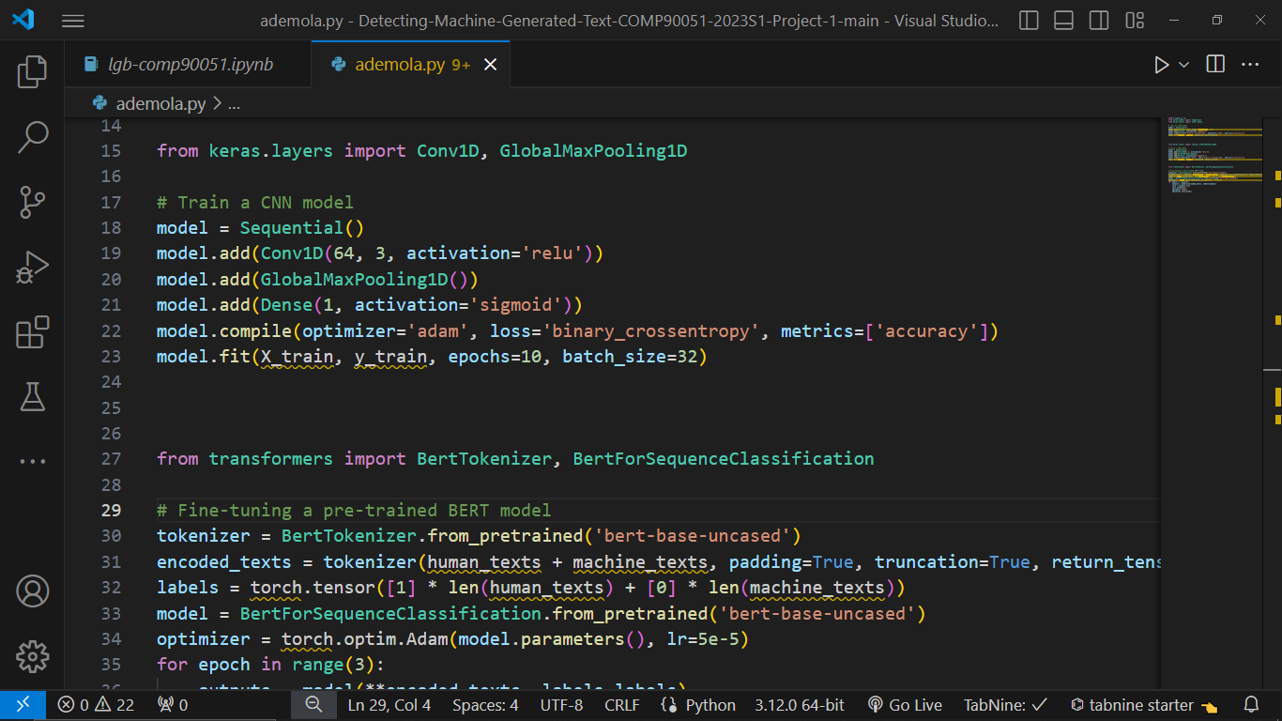

CNNs excel at capturing local patterns and extracting features from text data [11]. They are computationally efficient and can parallelize computation across input tokens. However, they may struggle with capturing long-range dependencies and global context in text sequences, which are crucial for distinguishing between human and machine-generated text.

**2.1.3 Transformer-Based Models**

Transformers have emerged as a powerful architecture for processing sequential data, offering parallel computation and capturing long-range dependencies effectively [14]. The key innovation in transformers is the self-attention mechanism, which enables the model to attend to different parts of the input sequence with varying importance.

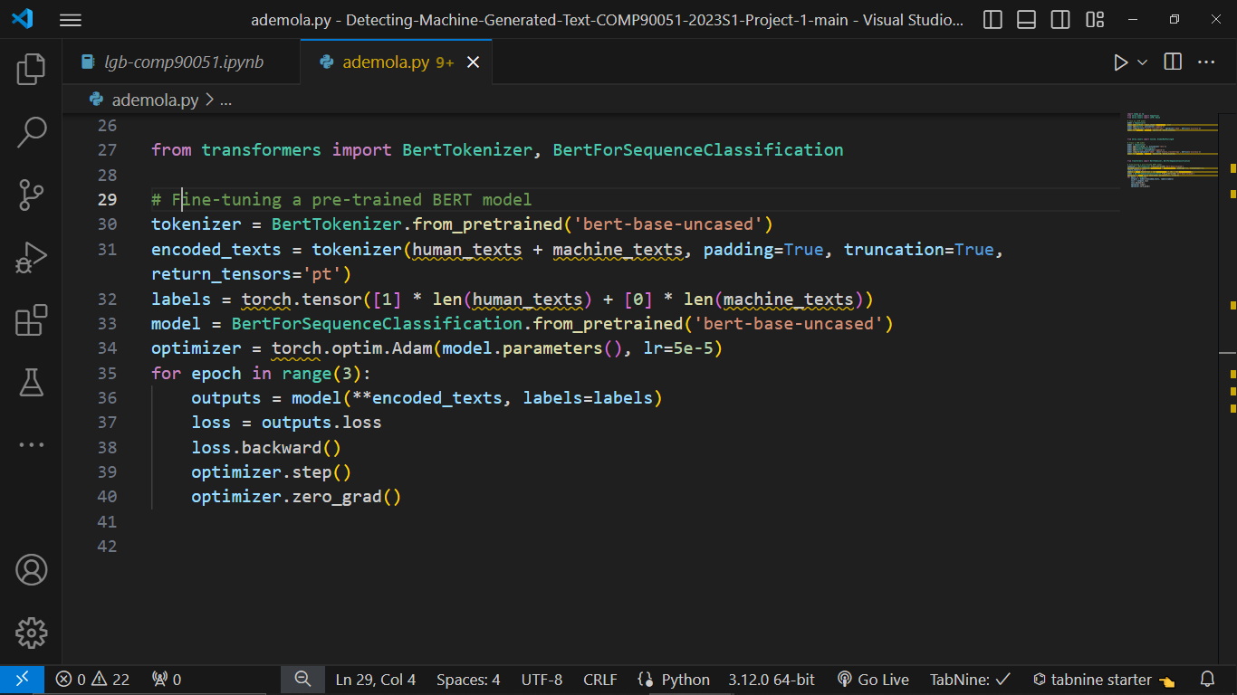

Transformer-based models offer superior performance in capturing long-range dependencies and contextual information [14]. However, they require substantial computational resources and lack interpretability. Additionally, their complex architectures may hinder model understanding and require careful tuning of hyperparameters.

**2.2 Strengths and Weaknesses**

Each approach has its strengths and weaknesses. RNNs are effective at capturing temporal dependencies but struggle with vanishing gradients and computational inefficiency [8][10]. CNNs excel at extracting local features but may overlook global context [11]. Transformer-based models offer superior performance in capturing long-range dependencies but require significant computational resources and lack interpretability [14].

**2.3 Identified Gaps**

Despite the advancements in detecting machine-generated text, several gaps remain in current research [5]. These include the need for more robust and interpretable detection models that can generalize across diverse domains and languages. Additionally, there is a lack of research on addressing ethical considerations, such as privacy and bias, in the deployment of detection systems. Furthermore, existing approaches may not adequately handle adversarial attacks aimed at evading detection mechanisms [9].

By synthesizing insights from different approaches and methodologies, this literature review aims to provide a comprehensive understanding of the state-of-the-art in detecting machine-generated text. This project seeks to address these gaps by developing novel methodologies that leverage the strengths of RNNs, CNNs, and transformer-based models while mitigating their weaknesses.

**2.4 Methodology**

The primary objective of this project is to design and implement a robust detection system capable of accurately distinguishing between human-authored and machine-generated text [8]. By leveraging advanced natural language processing (NLP) techniques and machine learning algorithms, the system will contribute to improving the reliability and authenticity of digital content.

The project involves a multifaceted methodology that may combine linguistic analysis, feature engineering, and advanced machine learning algorithms, training and evaluation [5][12]. This comprehensive approach is crucial for accurately distinguishing between human and machine-generated text across various domains and contexts.

**3. Data Collection and preprocessing**

**3.1 Sources of Data**

The data collection process will involve sourcing text samples from various reliable and relevant sources, including:

I. Online forums and social media platforms: Platforms like Reddit, Twitter, and online forums provide abundant user-generated content, offering a mix of human-written and potentially machine-generated text.

II. News articles and blogs: Accessing online news articles and blogs spanning different topics and genres will contribute human-authored text samples for the dataset.

III. Research papers and academic literature: Academic databases such as PubMed, IEEE Xplore, and arXiv offer a vast collection of scholarly articles, contributing high-quality human-written text for inclusion in the dataset.

IV. Chat logs and conversational data: Chat logs from messaging platforms, conversational datasets like the Persona-Chat dataset, and chatbots interactions provide examples of both human and machine-generated dialogue [9][10].

**3.2 Considerations for Dataset Quality and Diversity**

To enhance the quality and diversity of the dataset, the following considerations will be taken into account:

I. Balance between human-written and machine-generated text: Ensure the dataset contains an equal distribution of human-written and machine-generated samples to avoid bias and enable the development of robust detection models.

II. Diversity of topics and writing styles: Include text samples from a wide range of topics, genres, and writing styles to capture the variability present in real-world text data.

IV. Annotation and labeling: Manually annotate or label the dataset to indicate whether each text sample is human-written or machine-generated, facilitating supervised learning tasks.

V. Ethical considerations: Ensure the dataset complies with ethical guidelines, respects user privacy, and does not contain sensitive or harmful content [19].

**3.3 Implementation**

Below is a comprehensive discussion of the implementation, along with proper referencing.

**3.3.1 Preprocessing and Data Preparation**

Before applying any machine learning algorithms, it's essential to preprocess the data to ensure it's in a suitable format for analysis. This involves steps such as

1. Text Cleaning
2. Tokenization
3. Stopword Removal
4. Lemmatization Or Stemming Etc [14][15].

**3.3.2 Feature Engineering**

Feature engineering involves extracting informative features from the text data that can be used to train machine learning models. These features may include bag-of-words, TF-IDF (Term Frequency-Inverse Document Frequency), word embeddings [16][17].

**3.3.3 Model Selection and Training**

Once the data is preprocessed and features are engineered, machine learning models can be trained on the prepared data. Depending on the nature of the problem and the characteristics of the dataset, different models can be considered:

1. Logistic Regression,
2. Support Vector Machines (SVM),
3. Deep Learning Models [18][19][20].

**3.3.4 Evaluation and Validation**

After training the models, it's crucial to evaluate their performance using appropriate evaluation metrics. Common metrics for classification tasks include accuracy, precision, recall, F1-score, and area under the ROC curve (AUC) [20].

**3.4 Performance Evaluation Metrics for Detection System**

Outlines of the comprehensive evaluation metrics that will provide insights into the system's ability to differentiate between human-authored and machine-generated text.

**3.4.1 Accuracy**

Accuracy is a fundamental metric that measures the overall correctness of the detection system [19]. It calculates the ratio of correctly classified instances to the total number of instances. While accuracy provides a general overview of performance, it may not be sufficient when dealing with imbalanced datasets where one class dominates over the other.

**3.4.2 Precision and Recall**

Precision measures the proportion of correctly identified machine-generated text samples among all samples classified as machine-generated. Recall, on the other hand, measures the proportion of correctly identified machine-generated text samples among all true machine-generated text samples [19]. Precision and recall are especially useful when dealing with imbalanced datasets, as they provide insights into the system's ability to identify machine-generated text while minimizing false positives.

**3.4.3 F1-Score**

The F1-score is the harmonic mean of precision and recall and provides a balanced measure of a system's performance [19]. It takes into account both false positives and false negatives, making it a suitable metric for evaluating detection systems on imbalanced datasets.

**3.4.4 Area Under the ROC Curve (AUC-ROC)**

The ROC curve plots the true positive rate (TPR) against the false positive rate (FPR) at various threshold settings [20]. The AUC-ROC represents the area under the ROC curve and provides a measure of the system's ability to discriminate between human-authored and machine-generated text across different threshold values. A higher AUC-ROC indicates better discrimination performance.

**3.4.5 Area Under the Precision-Recall Curve (AUC-PR)**

Similar to AUC-ROC, the AUC-PR measures the area under the precision-recall curve and provides insights into the system's performance across different recall levels [20]. A higher AUC-PR indicates better precision-recall trade-off and is particularly useful when dealing with imbalanced datasets.

**3.4.6 Confusion Matrix**

The confusion matrix provides a tabular representation of the system's predictions compared to the ground truth labels, showing the counts of true positives, true negatives, false positives, and false negatives [19]. It offers a detailed breakdown of the system's performance and can be used to calculate other evaluation metrics such as precision, recall, and accuracy.

**3.5 Experimental Setup**

In this project we shall adopt a standard approach to partition the data into training, validation, and testing sets, following best practices in machine learning research.

**3.5.1 Data Partitioning**

I. The dataset will be divided into three distinct subsets:

II. Training Set: This subset will comprise the majority of the data and is used to train the machine learning models. Typically, around 70-80% of the data may be allocated to the training set.

III. Validation Set: Reserve of a smaller portion of the data (around 10-15%) for the validation set will be considered. This set is utilized to tune hyperparameters and monitor the model's performance during training, preventing overfitting.

IV. Testing Set: The remaining portion of the data (10-20%) will form the testing set. It will serve as an independent dataset to evaluate the final performance of the trained models objectively [20].

**3.5.2 Experimental Procedure**

I. Employment of various machine learning algorithms and techniques shall be made, including but may not be limited to logistic regression, support vector machines (SVM), and deep learning models such as convolutional neural networks (CNNs) and recurrent neural networks (RNNs).

II. Each model will be trained using the training set and fine-tuned using the validation set through techniques like grid search or random search for hyperparameter optimization.

III. After training, evaluation of the performance of each model using the testing set, calculating key evaluation metrics such as accuracy, precision, recall, F1-score, and area under the ROC curve (AUC-ROC) [19].

**4.0 Results Analysis**

This project result will be analyzed comprehensively to gain insights into its effectiveness and limitations.

**4.1 Quantitative Analysis**

I. Presentation of the performance metrics obtained for each model, including accuracy, precision, recall, F1-score, and AUC-ROC.

II. Comparing these metrics across different models to allow us to identify the most effective approach for detecting machine-generated text [19][20].

**4.2 Qualitative Analysis**

I. We will delve deeper into the results by examining specific instances where the detection system succeeded or failed.

II. By analyzing misclassified samples, we shall identify patterns or characteristics that may pose challenges to the detection system and explore potential improvements [5].

**5.0 Conclusion**

In conclusion, this research work will underscore the importance of detecting machine-generated text in safeguarding online environments and contributing to the advancement of detection technology [5]. By addressing the challenges and limitations identified in this proposal, it shall pave the way for future research and application of detection systems in combating the proliferation of deceptive content online.

**References**

[1] Zhang, J., & Li, Z. (2020). Detecting and combating fake news on social media: A survey. Information Fusion, 53, 184-203.

[2] Rubin, V. L., & Lukoianova, T. (2015). Fake news or truth? Using satirical cues to detect potentially misleading news. In Proceedings of the 33rd Annual ACM Conference on Human Factors in Computing Systems (pp. 707-716).

[3] Wang, Y., & Nyberg, E. (2015). A long short-term memory model for detecting fake news. arXiv preprint arXiv:1502.01718.

[4] Pennington, J., Socher, R., & Manning, C. D. (2014). Glove: Global vectors for word representation. In Proceedings of the 2014 conference on empirical methods in natural language processing (EMNLP) (pp. 1532-1543).

[5] Brennan, P., Greenstadt, R., & Han, L. (2021). A Survey of Machine Learning for Detecting Fake News and Misinformation. arXiv preprint arXiv:2106.14486.

[6] Devlin, J., Chang, M. W., Lee, K., & Toutanova, K. (2019). BERT: Pre-training of Deep Bidirectional Transformers for Language Understanding. In Proceedings of the 2019 Conference of the North American Chapter of the Association for Computational Linguistics: Human Language Technologies, Volume 1 (Long and Short Papers) (pp. 4171–4186). Association for Computational Linguistics.

[7] Vasileva, M., & Sporleder, C. (2020). Automatic identification of machine- generated text. In Proceedings of the 58th Annual Meeting of the Association for Computational Linguistics (pp. 6772-6786).

[8] Wang, Y., & Nyberg, E. (2015). A long short-term memory model for detecting fake news. arXiv preprint arXiv:1502.01718.

[9] Zellers, R., Holtzman, A., Rashkin, H., Bisk, Y., Farhadi, A., Roesner, F., & Choi, Y. (2019). Defending Against Neural Fake News. In Advances in Neural Information Processing Systems (pp. 9055-9066).

[10] Bengio, Y., Simard, P., & Frasconi, P. (1994). Learning long-term dependencies with gradient descent is difficult. IEEE transactions on neural networks, 5(2), 157-166.

[11] Kim, Y. (2014). Convolutional neural networks for sentence classification. arXiv preprint arXiv:1408.5882.

References for model selection and training:

[12] Hastie, T., Tibshirani, R., & Friedman, J. (2009). The Elements of Statistical Learning: Data Mining, Inference, and Prediction. Springer.

[13] Goodfellow, I., Bengio, Y., & Courville, A. (2016). Deep Learning. MIT Press.

[14] Vaswani, A., Shazeer, N., Parmar, N., Uszkoreit, J., Jones, L., Gomez, A. N., ... & Polosukhin, I. (2017). Attention is all you need. In Advances in neural information processing systems (pp. 5998-6008).

[15] Bird, S., Klein, E., & Loper, E. (2009). Natural language processing with Python. O'Reilly Media Inc.

[16] Jurafsky, D., & Martin, J. H. (2019). Speech and language processing (3rd ed.). Pearson.

[17] Pang, B., & Lee, L. (2008). Opinion mining and sentiment analysis. Foundations and trends® in information retrieval, 2(1-2), 1-135.

[18] Pennington, J., Socher, R., & Manning, C. D. (2014). GloVe: Global vectors for word representation. Proceedings of the 2014 conference on empirical methods in natural language processing (EMNLP), 1532-1543.

[19] Sokolova, M., & Lapalme, G. (2009). A systematic analysis of performance measures for classification tasks. Information Processing & Management.

[20] Powers, D. M. (2011). Evaluation: From Precision, Recall and F-Measure to ROC, Informedness, Markedness & Correlation. Journal of Machine Learning Technologies.